

**INFORMATION SYSTEMS ANALYSIS AND DESIGN ASSIGNMENT(COS107)**

YOUR TITTLE OR

HEADLINE CAN

BE PUT HERE



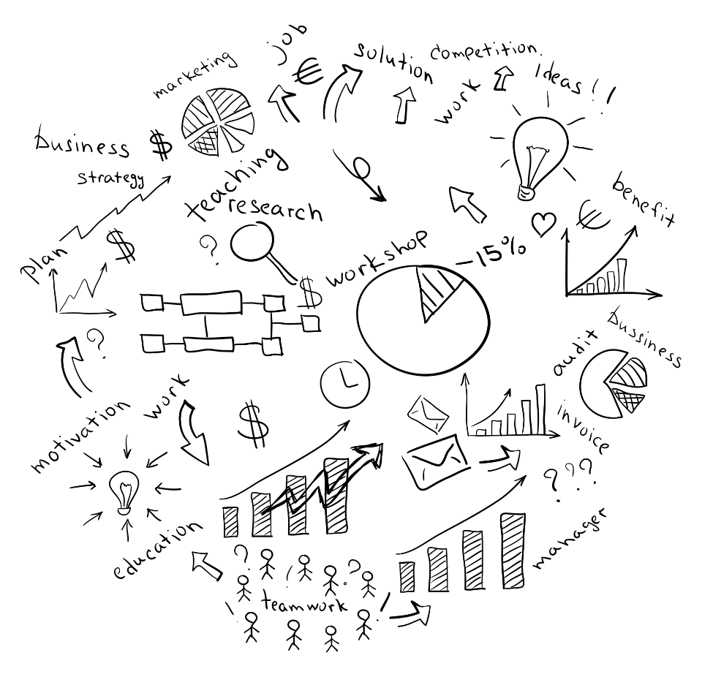

Assigned By: Aung Tun Lin

Assigned To: Tr. Moh Moh Khaing

Gmail: [singhkhushbeer504@gmail.com](mailto:singhkhushbeer504@gmail.com)

Submission Date: 6.9.2022

Contents

Introduction On RAD 3

3

Strength and Weakness 4

Relevancy 5

Tools and Techniques of System Analysis 6

Methodology 6

Recommendation and Conclusion 7

References 8

Task2 Diagram Snapshot 9

Task3 Diagram Snapshot 10

Task4 Diagram Snapshot 11

# Introduction On RAD

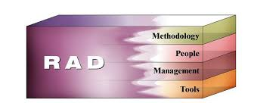The full form of “RAD” is Rapid Application Development in which the framework fosters the idea should have been grown quicker and excellent norm. It was suggested by James Martin in 1980s before publishing it in 1990. Portraying Rapid Application as "a philosophy that empowers associations to foster decisively significant frameworks quicker while diminishing improvement costs and keeping up with quality. This is accomplished by utilizing a progression of demonstrated application improvement procedures, inside an obvious philosophy."

Rapid Application Development has four fundamental viewpoints

* Tools
* People
* Management
* Methodology which will describe later in this report

# Your Complete Guide To Rapid Application Development (RAD)

Phases of Rapid Application as follows:

* Requirements planning
* User design
* Construction
* Cutover

# Strength and Weakness

Strength of RAD

The strength of RAD model is very adaptable versatile to change whereas rapid application development is useful when the user has to reduce overall risk of a serious project. The peak level of reflections and intermediate level of codes is used for easy transfer of expectation as a script. Reduction of codes must face due to code generators. RAD helps the user to protype the project for lesser defects. With the amount of less people the productivity can increase with amount of time.

Weakness of RAD

The main concern of RAD is that it cannot be used for more modest project and all system application is not compatible. For prototyping RAD can easily use whereas it is not fit for the high technical risk. If the concern developers can submit the reports of software on time it can lead to fail so there is a requirement of highly skill developers. (Martin, 2022)

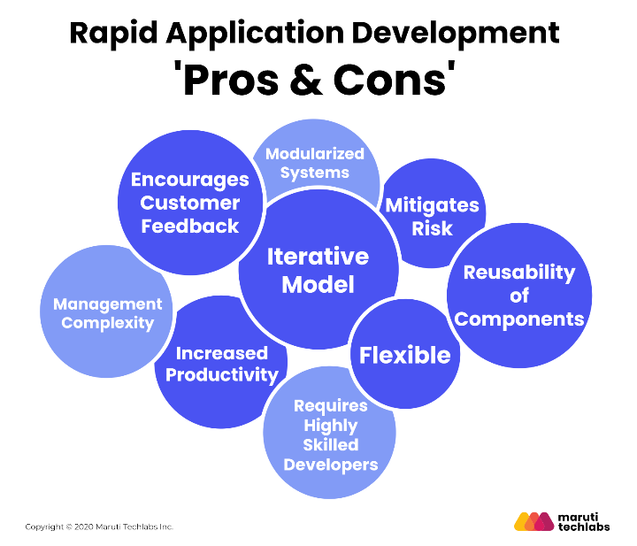

* The fully shaded Blue rounded circles describe the Pros of RAD whereas light shaded round circles describe the Cons of RAD.

# Relevancy

Relevancy is the degree to which some data is appropriate, associated, or pertinent to the current matter. It addresses a vital idea in the ﬁelds of documentation, data science, and data recovery. RAD includes end users, senior user with full dedication is required. Absence of dedication more waterfall methodologies must be in consideration. It is significant that end user must have simple access hence, the developers and the user must be in the same area for its debugging and compromising the requirements of detailed analysis for the external users. There must be compelling on project control due to the failure of Prototyping potential project. Thus, RAD must empower the team to allow the independent work on their own.

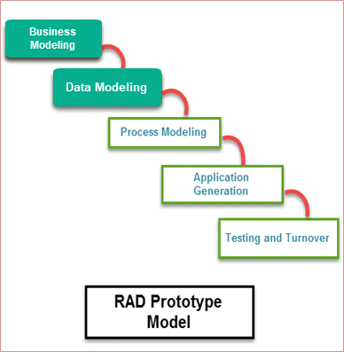

* Nonetheless, when the outcomes are consequently evaluated for importance, the twofold pertinence scale isn't suﬃcient, fundamentally because of the various leveled connections that exist among the components in an XML archive. As needs be, in XML recovery at least one significance aspects (each with a multi-reviewed importance scale) have been utilized to survey the pertinence of the query item. (Pehcevski, 2007)

# Tools and Techniques of System Analysis

RAD is utilizes both modernized instruments and human procedures to accomplish the objectives of fast and top caliber. For example, CASE tools can be used in RAD projects in which it plays an important role in removing queries existing in development application. These CASE tools could be possibly to promote architype and straightforwardly creating code in view of those models rather than hard coding. What do rapid application development tools entail? Toolkits, programs, frameworks, and software that facilitate the creation of online or mobile applications are examples of tools used in rapid application development. Reusable templates that are adapted to your particular needs should be included in your tools. There are various tools for rapid application development, like Kissflow, Zoho Creator, OutSystem, Bizagi, and Appian, but these are only a few of the best ones for analysts and developers. There are numerous other tools as well. Because all of the handful recognized tools function in the same way, I'll merely talk about one of them. The best rapid application development tool available at the moment is Kissflow. Kissflow is a complete business process management application that enables you to create your own workflow and processes as well as create templates that can be used in other processes. (Saramilla, 2012)

# Methodology

RAD development attacks challenge head-on by giving system to develop faster while minimizing cost and uplifting its quality. These challenges consist:

* Combine the most effective methods now in use while determining the tasks that will increase the effectiveness of those methods.
* Workshops are used to gather requirements and evaluate designs rather than interviews.
* Choosing CASE tools for modeling, prototyping, and code reuse.
* Development teams may be able to build the system's core quickly by employing time boxed development.

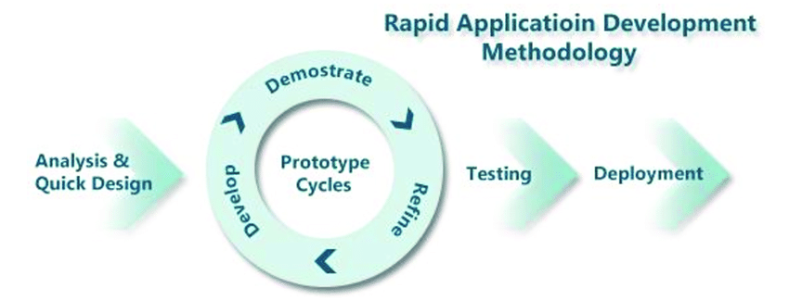An establishment of the prototyped cycle is consequently aiming to make sure of designers assemble the frameworks that the clients truly need. This prototyped lifecycle, with four kinds of cycles, associate all of the implementation ambition and distinguish needed for enterprises and arrangement, develop and perform the framework of application that sustain this obligation. (Saramilla, 2012)

The Rapid Application Development Methodology comprised of

* Analysis & Design
* Prototype Cycles (consists of Develop, Demonstrate, Refines)
* Testing
* Deployment

# Recommendation and Conclusion

Rapid Application provide your enterprises to put forth interest to customer. RAD does not disappoint to their own customer what they require. For the sake of innovation, it requires the professional software developer who can change its types at any circumstances. RAD main motive is to minimizing the cost of the projects. RAD toughness is to speed up the refinement schedules by summoning its process, individuals and creative innovation assisted techniques. However, it requires a highly skill professional developers to complete the task. RAD provides automated tools and techniques for easy coding to professional software developers.

# References

Martin, M., 2022. *What is RAD Model? Phases, Advantages and Disadvantages.* [Online]   
Available at: https://www.guru99.com/what-is-rad-rapid-software-development-model-advantages-disadvantages.html  
[Accessed 5 9 2022].

Pehcevski, J., 2007. *The Concept of Relevance.* [Online]   
Available at: https://www.academia.edu/2990107/Relevance  
[Accessed 5 9 2022].

Saramilla, 2012. *Introduction to Rapid Application Development.* [Online]   
Available at: https://www.ftms.edu.my/images/Document/IMM006%20-%20RAPID%20APPLICATION%20DEVELOPMENT/IMM006%20RAPID%20APPLICATION%20DEVELOPMENT%20-%20note%20chapter%201.pdf  
[Accessed 5 9 2022].

# Task2 Diagram Snapshot

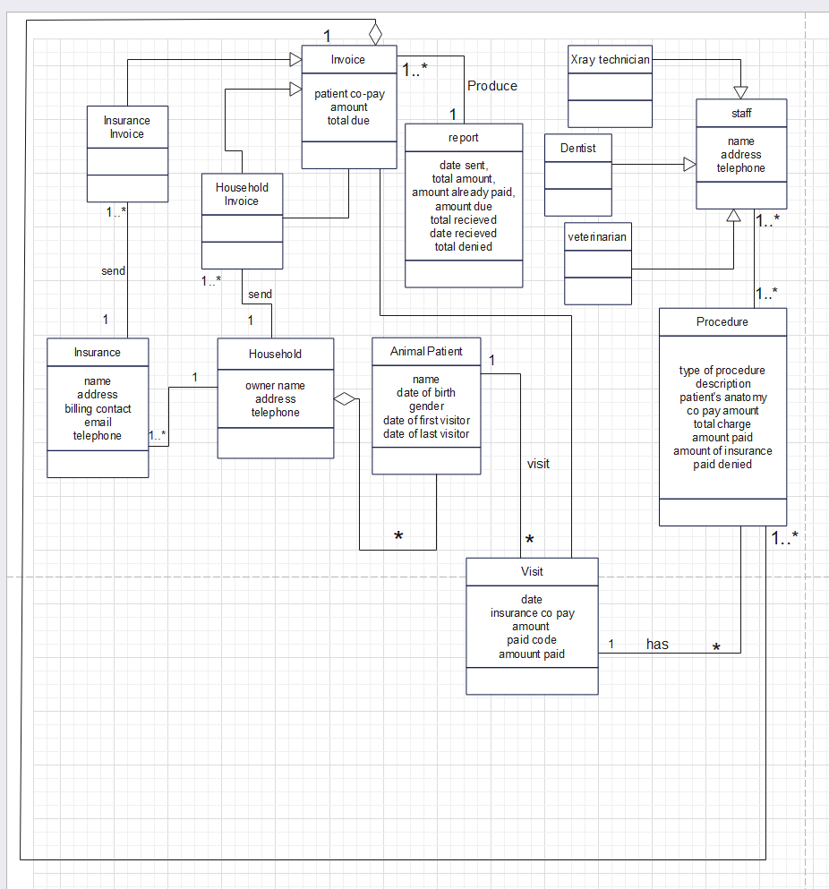This diagram is drawn by EdrawMax tools to complete the class diagram.

# Task3 Diagram Snapshot

This diagram is drawn by EdrawMax tools to complete the use case diagram.

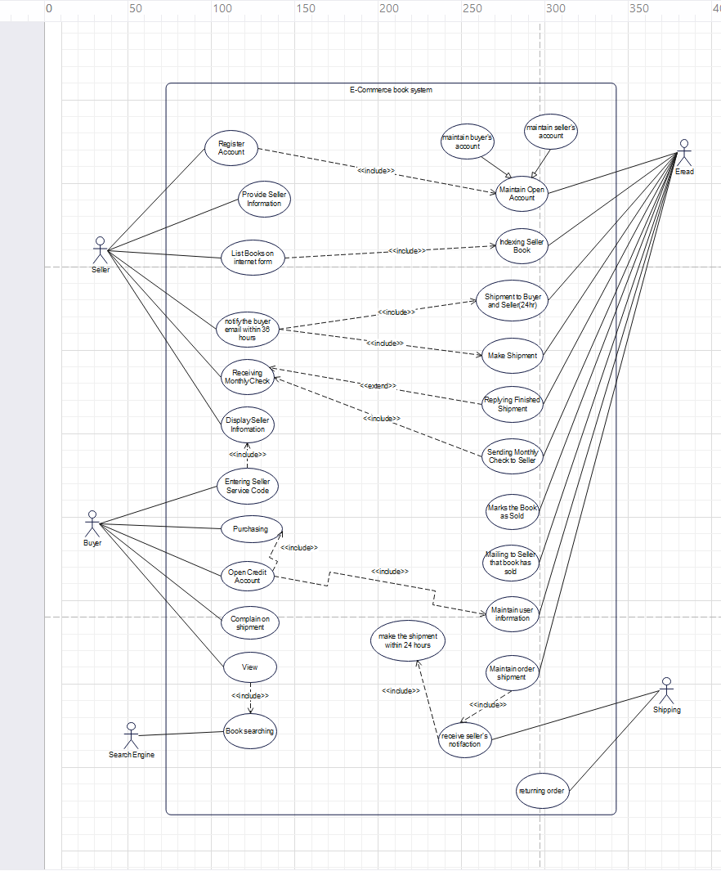

# Task4 Diagram Snapshot

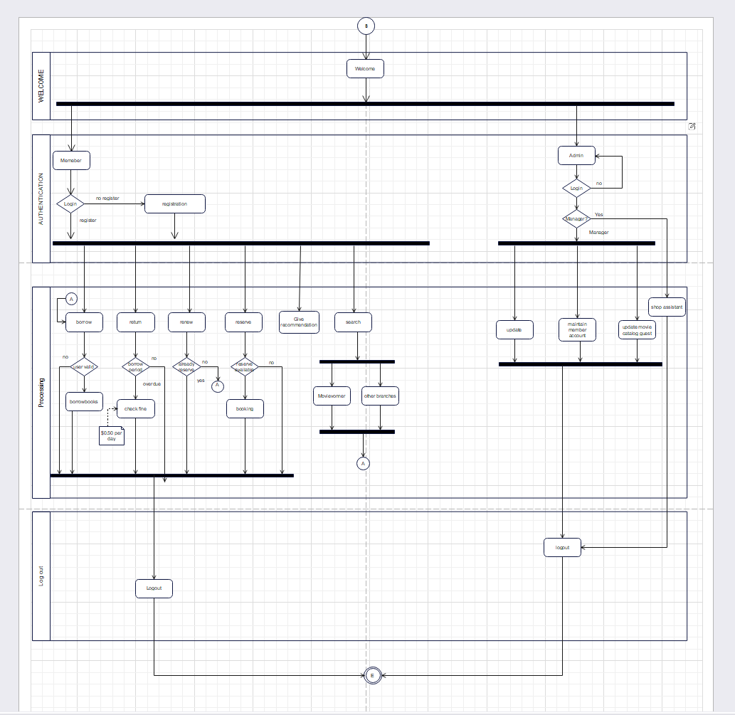

This diagram is drawn by EdrawMax tools to complete the activity diagram.